

Guidelines for Human/ Nonhuman Primate
Materials Use in Animals
Reviewed June 2020
Scope
This Standard Operating Procedure describes the safe handling procedures involving the introduction of human or nonhuman primate (NHP) materials, not known to harbor human pathogens, into live animals. This includes human/NHP tissues, body fluids, primary cells, established cell lines, and cells that have been stably transduced with viral vectors.
This guidance document does not cover:
- Procedures where human/NHP materials are introduced into animals that are susceptible to infection by human pathogens. These are always handled using ABSL2 procedures.
- Introduction of human/NHP materials known to be infected with human pathogens. Any requirements for working with these agents in animals are determined by the Institutional Biosafety Committee (IBC), depending on the specific agents used.
Definitions
- Established Cell Lines
"Established," "immortalized," or "continuous" cells derived from a primary culture, which may be subcultured indefinitely in vitro.
Primary Cells
Cells that are cultured directly from a subject are known as “primary” cells.
Procedures for Using Human/NHP Materials in Animals
- Administration of human/NHP materials may be done either in the animal facility or in the laboratory. ULAR policies regarding the transportation of animals must be followed; for example, rodents removed from a Level A room cannot be returned to a Level A room.
- The administration of injections, nasal inoculations, necropsies, harvesting tissues or fluids, and similar procedures should be performed in a biosafety cabinet (BSC) using BSL2/ABSL2 procedures. Exceptions can only be made by the Institutional Biosafety Committee (IBC) or the campus Biosafety Officer for reasons including but not limited to, the following:
  - The procedure would be hindered if performed within a BSC (e.g., if a stereotaxic unit may not fit or may interfere with the operation of the BSC).
  - A BSC cannot be reasonably procured. This includes having the explored possibilities of sharing with other labs and accommodations in the animal facility.
- When a BSC cannot be used, the IBC and/or Biosafety Officer will determine the safety precautions appropriate for ABSL2 conditions.
- General anesthesia of the animals is recommended for injections of human/NHP materials.
- Engineered sharps are recommended for injecting animals with human/NHP materials whenever possible.
- After injection of human/NHP materials, wipe the injection site on the animal with an alcohol wipe to remove/disinfect any material that may have leaked onto the skin.
- After administration of the cells/materials, the animals should be handled using ABSL1 procedures (for animals treated with established human/NHP cell lines) or ABSL2 procedures (for animals treated with primary human/NHP materials). A biosafety cabinet is not required for procedures unlikely to create aerosols (e.g., routine cage changing).
- For consultation on specific research plans, please contact the IBC at ibc@uci.edu.
Labeling and Handling of Animals and Cages

ESTABLISHED HUMAN/NHP  CELL LINES  (ABSL1 procedures) | PRIMARY HUMAN/NHP CELLS OR OTHER  HUMAN/NHP MATERIALS  (ABSL2 procedures)
- Label cages with Biohazard cage cards (ABSL1 procedures).  - Regular care and husbandry.  - No extra personal protective equipment (PPE) is required beyond the animal care PPE requirements as posted for the animal holding room. | - Label cages with Biohazard cage cards (ABSL2 procedures).  - ULAR will provide animal care services.  - Place dirty cages (with bedding) into red biohazard bags. Place used water bottles (with any remaining water) into a container and then into an autoclave bag.  - ULAR staff will autoclave the soiled cages, dispose of the bedding as biohazardous waste, and then wash the cages routinely.  - ULAR staff will autoclave the used water bottles, dispose of the autoclaved water into the drain, and then wash the bottles routinely.
Hazardous Waste Management
- Remaining aliquot should be decontaminated with a 10% bleach solution for 15 minutes, then flushed down a sink.
- Dispose of all contaminated animal carcasses as "pathological waste."
- Dispose of sharps in a biohazard sharps container.
- EH&S hazardous waste collection requests and guidelines are available online at http://www.ehs.uci.edu/programs/enviro/.
In Case of Exposure
- Skin exposure: Remove contaminated clothing and wash skin with soap and water.
- Eye exposure: Irrigate immediately at an eyewash station for 15 minutes.
- Ingestion: Refer to a physician.
- Inhalation: Remove victim to clean air. Call 911 if the individual is having difficulty breathing. Refer to the physician.
- Report all exposures to the supervisor.
- Complete the online injury/incident report form at www.ehs.uci.edu within 24 hours.

Acknowledgment

The Principal Investigator is responsible for ensuring that all personnel performing these procedures are trained on the safe handling of hazardous materials involved in this study. This includes completion of the Lab Safety Fundamentals online training, other applicable safety training courses, and hands-on training as needed. This standard operating procedure may be modified (in consultation with EH&S) to fit the research protocol's needs.

Both the PI and all personnel performing the tasks described herein must sign the following acknowledgment:

I have read, asked questions, and understand the hazards of and safe working procedures for the activities and materials described herein.

Print Name | Signature | Date

Examples of Biohazard Cage Cards
ESTABLISHED HUMAN/NHP CELL LINES  (ABSL 1 procedures) | PRIMARY HUMAN/NHP MATERIALS  (ABSL 2 procedures)
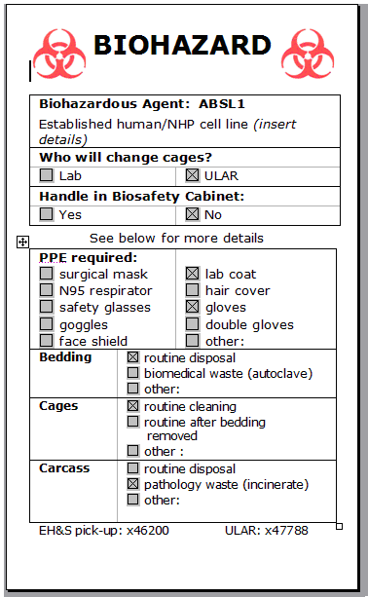 | 