Standard Operating Procedure

Carcinogens

Print a copy of this SOP and insert into your Safety on Site (SOS) Binder.
Department:
Date SOP was written:
Date SOP was approved by PI/lab supervisor:
Principal Investigator:
Principal Investigator Signature:
Internal Lab Safety Coordinator/Lab Manager:
Lab Phone:
Office Phone:
Emergency Contact: | (Name and Phone Number)
Location(s) covered by this SOP: | (Building/Room Number)

Type of SOP: ☐ Process ☐Hazardous Chemical X Hazardous Class

Contents

Purpose
Subject Chemicals Used in this Laboratory
Properties & Hazards
Administrative Controls
Engineering Controls
Personal Protective Equipment (PPE)
Special Handling & Storage Requirements
First Aid Procedures
Medical Emergency
Spill & Accident Procedure
Decontamination/Waste Disposal Procedure
Safety Data Sheet (SDS) Location
Required Training/Approvals
Additional Notes
Documentation of Training

APPENDIX A: Lab-Specific Use Procedures
APPENDIX B: Work Practices for Listed Carcinogens
APPENDIX C: Regulated Carcinogen Use Registration Form

Purpose

The purpose of this standard operating procedure is to acquaint you with the proper and safe handling, use, storage and disposal of the subject chemicals.

Subject Chemicals Used in this Laboratory

Refer to the banded laboratory chemical inventory located in the SOS binder for a listing of all chemicals in this laboratory that this SOP applies to. In addition, the banded inventory includes chemical-specific notations that supplements the information provided in this SOP (e.g., special hazards, handling, PPE).

Properties & Hazards

Chemicals in this band are known to cause, or are suspected of causing cancer. All chemicals in this band are considered highly hazardous and the band is generally defined as follows:

- regulated by Cal/OSHA as a carcinogen;
- National Toxicology Program (NTP) "known to be carcinogens" or “reasonably anticipated to be carcinogens”; or
- International Agency for Research on Cancer (IARC) Group 1, 2A or 2B (definitely, probably, possibly carcinogenic).

The GHS and Cal/OSHA definition of the band is described in the table below:

UCI Hazard Level | GHS Category | GHS H-Code | Cal/OSHA Definition
Highly  Hazardous | Carcinogenicity (Cat.1A,1B,2) | H350, H351 | Carcinogen, Select Carcinogen
Generally Hazardous | All chemicals in this band are considered highly hazardous.

All chemicals in this band are considered “particularly hazardous substances” per Cal/OSHA.

A list of chemicals known to the State of California to cause cancer can be found at: http://www.oehha.ca.gov/prop65/prop65_list/files/filesp65single110112.pdf

Administrative Controls

In addition to the practices described below, follow procedures as specified in the lab-specific and special handling/use sections of this SOP.

General practices:

- Be sure to review the Safety Data Sheet (SDS) for all chemicals to be used in the experiment.

- Never work alone. At least one other person must be present in the same laboratory when any work involving hazardous chemicals is being done.

- Eliminate or substitute for a less hazardous material when possible.

- Design your experiment to use the least amount of material possible to achieve the desired result.

- Verify your experimental set-up and procedure prior to use. Be familiar with the Safety Data Sheets for all chemicals in use. Assess the hazards to ensure that appropriate controls are in place to minimize risk and address emergency shut-down procedures as appropriate.
- Consult with the PI if the work involves procedure scale-up or other large quantities or there are any questions regarding appropriate safety procedures.

Band-specific practices:

- All carcinogens must be used in a “designated area” within the laboratory. A designated area may be the entire laboratory, an area of a laboratory or a device such as a laboratory hood. Refer to the lab specific procedures section of this document for a description of designated areas in this laboratory.

Engineering Controls

In addition to the practices described below, follow procedures as specified in the lab-specific and special handling/use sections of this SOP.

General practices:

- In general, it is preferable to perform all work with hazardous chemicals in a fume hood. Sash height should be kept as low as possible to avoid the escape of vapors, gases and particulates.

- Supplemental equipment such as blast shields should be used when working with chemicals or processes that may result in explosions or pressure releases.

- Consider the use of a glove box, toxic gas cabinet or other local exhaust in order to further contain hazards as appropriate.

Band-specific practices:

- These chemicals must be used in a containment device within the designated area. Containment devices may include fume hoods, glove boxes or other similar devices. Refer to the lab specific procedures section of this document for a description of specific containment devices used in this laboratory. If the process does not permit the handing of such materials in a fume hood, contact EH&S for a review the adequacy of ventilation measures.

- Use high efficiency particulate air (HEPA) filters, carbon filters, or scrubber systems with containment devices to protect effluent and vacuum lines, pumps, and the environment whenever feasible.

- Use ventilated containment to weigh out solid chemicals. Alternatively, the tare method can prevent inhalation of the chemical. While working in a laboratory hood, the chemical is added to a pre-weighed container. The container is then sealed and can be re-weighed outside of the hood. If chemical needs to be added or removed, this manipulation is carried out in the hood. In this manner, all open chemical handling is conducted in the laboratory hood.

- Transport materials between locations using a non-breakable bottle carrier whenever possible.

- Evacuated glassware can implode and eject flying glass, and splattered chemicals. Vacuum work involving these chemicals must be conducted in a fume hood, glove box or isolated in an acceptable manner. Mechanical vacuum pumps must be protected using cold traps and, where appropriate, filtered to prevent particulate release. The exhaust for the pumps must be vented into an exhaust hood.
Personal Protective Equipment (PPE)

In addition to the practices described below, follow procedures as specified in the lab-specific and special handling/use sections of this SOP.

Respiratory Protection

Respiratory protection is generally not required for lab research, provided the appropriate engineering controls are employed. Respirators should be used only under any of the following circumstances:

Lab personnel intending to use/wear a respirator mask must be trained and fit-tested by EH&S. This is a regulatory requirement. If you think that your process may require respirator use, contact EH&S for assistance (http://www.ehs.uci.edu/programs/ih/respiratory.html)

Hand Protection

Disposable nitrile gloves provide sufficient protection for most routine lab operations involving small quantities. They should be changed if liquid is splashed onto them. They are not appropriate for longer operations or operations using larger quantities.

For longer operations, or operations using larger quantities, use thicker gloves made from a material appropriate for the specific chemical in use (e.g., natural rubber, butyl, neoprene, nitrile, PVA). When working chemicals or processes that increase the risk of exposure to fire, use hand protection appropriate to both the risk of chemical exposure and the risk from fire. Gloves must be inspected prior to use for signs of wear or damage. Such gloves should be disposed of in accordance with appropriate laboratory disposal practices.

Use proper glove removal technique (without touching glove's outer surface) to avoid skin contact with any chemical residues on the surface. Wash and dry hands after use.

For additional information on selection of glove material, review the specific chemical Safety Data Sheet. Consult with your preferred glove manufacturer’s website to ensure that the gloves you plan on using are compatible with a specific chemical substance. Common manufacturer glove selection guidance can be found at::

http://www.ansellpro.com/download/Ansell_8thEditionChemicalResistanceGuide.pdf
http://www.allsafetyproducts.biz/page/74172
http://www.showabestglove.com/site/default.aspx
http://www.mapa-pro.com/our-gloves/protections/chemical-protection/b/handled_product.html

Eye Protection

Use safety glasses with side shields or tightly fitting safety goggles whenever working in the laboratory.

Skin and Body Protection

Long pants, closed toed-shoes, shirt and a lab coat must be worn whenever working in the laboratory. Flame resistant Nomex® lab coats should be used when working with chemicals or processes that increase the risk of fire. Fully extend sleeves to the wrists and keep buttoned at all times. Avoid wearing synthetic clothing when practicable.

Hygiene Measures

Wash hands immediately and thoroughly after handling chemicals. Any contaminated clothing should be disposed of or washed before reuse.

Band-specific practices:

- If in the process of working with these chemicals, chemical contact is made with gloves or other PPE, immediately dispose of or clean the affected PPE in order to minimize the potential for spreading contamination.

Special Handling & Storage Requirements

In addition to the practices described below, follow procedures as specified in the lab-specific section of this SOP.

Band-specific practices:

- All containers of these chemicals should be clearly labeled and stored in a designated area.

- Cal/OSHA “Listed” Carcinogens.
  - Cal/OSHA specifically regulates the following 13 carcinogens:
    - 2-acetylaminofluorene
    - 3,3'-dichlorobenzidine and its salts
    - 4-aminodiphenyl
    - 4-dimethylaminoazobenzene
    - 4-nitrobiphenyl
    - Alpha-naphthylamine
    - Benzidine and its salts
    - Beta-naphthylamine
    - Beta-propiolactone
    - Bis-chloromethyl ether
    - Ethyleneimine
    - Methyl chloromethyl ether
    - N-nitrosodimethylamine
  - Required work practices for these chemicals are provided in Appendix B.

- Additional Cal/OSHA Regulated Carcinogens
  - In addition to the above 13 chemicals, Cal/OSHA regulates additional carcinogens. These include, but are not limited to the following:
    - Acrylonitrile
    - Arsenic
    - Benzene
    - Butadiene
    - Cadmium
    - Carbon tetrachloride
    - Formaldehyde
    - Ethylene dibromide
    - Ethylene oxide
    - Methylene chloride (Dichloromethane)
    - Methylenedianiline
    - Vinyl chloride.
  - Additional regulatory requirements apply to the use of these chemicals. Contact EHS for assistance if you use any of the above chemicals.

- Carcinogen Registration Form
  - In order to facilitate compliance with Cal/OSHA regulations, complete the “Regulated Carcinogen Use Registration” form provided in Appendix C and send to EHS. Update this form and provide to EHS whenever changes in use occur and at least annually.
First Aid Procedures

In addition to the practices described below, follow procedures as specified in the lab-specific and special handling/use sections of this SOP.

Consult the Safety Data Sheet for the subject chemical for specific first aid procedures. General first aid procedures for hazardous chemicals are provided below.

If inhaled
Move to fresh air. Have victim rest in half-upright position. Artificial respiration victim is not breathing. Seek medical attention immediately.

In case of skin contact
In case of contact, immediately flush skin with plenty of water for at least 15 minutes while removing contaminated clothing and shoes. Wash clothing before reuse. Thoroughly clean shoes before reuse. Get medical attention immediately

In case of eye contact
Check for and remove any contact lenses. In case of contact, immediately flush eyes with plenty of water from emergency eyewash station for at least 15 minutes. Get medical attention immediately.

If swallowed
If swallowed, do not induce vomiting unless directed to do so by medical personnel. Never give anything by mouth to an unconscious person. Loosen tight clothing such as a collar, tie, belt or waistband. Get medical attention immediately.

Medical Emergency

Be familiar with information in the UC Irvine Injuries & Medical Treatment poster (http://www.ehs.uci.edu/MedEmergPoster.pdf)

a. Life Threatening Emergency (all times: Business Hours, After Hours, Weekends and Holidays)--CALL 911 if the condition is LIFE THREATENING or REQUIRES IMMEDIATE MEDICAL ATTENTION. Note: All serious injuries must be reported to EH&S at x46200 within 8 hours. Complete online incident report at https://www.ehs.uci.edu/apps/hr/index.jsp

b. Non-Life Threatening Emergency – Notify your supervisor or faculty staff if condition is not life threatening or does not require immediate medical attention.

ALL WORK RELATED INJURIES MUST BE REPORTED via the On-line Incident Form https://www.ehs.uci.edu/apps/hr/index.jsp or call Human Resources, Workers Compensation (949) 824-9152.

Spill & Accident Procedure

In addition to the practices described below, follow procedures as specified in the lab-specific and special handling/use sections of this SOP.

Evacuate the spill area. Post someone or mark-off the hazardous area with tape and warning signs to keep other people from entering the area. Keep the appropriate fire extinguisher nearby. Avoid incompatible extinguishing agents. Use Class A-B-C or B-C for flammable liquids. Fire extinguishers containing water are not suitable for flammable liquid fires.

Spill – Assess the extent of danger. Help contaminated or injured persons if safe to do so. Evacuate the spill area. Avoid breathing vapors. If possible, confine the spill to a small area using a spill kit or absorbent material. Keep others from entering contaminated area (e.g., use caution tape, barriers, etc.).

Small (<1 L, <100 g) – If you have training, you may assist in the clean-up effort. Use appropriate personal protective equipment and clean-up material for chemical spilled. Double bag spill waste in clear plastic bags, label and take to the next chemical waste pick-up.

Large (>1 L, >100 g) – Dial 911 and EH&S at x46200 for assistance.

Chemical Spill on Body or Clothes – Remove clothing and rinse body thoroughly in emergency shower for at least 15 minutes. Seek medical attention. Notify supervisor and EH&S at x46200 immediately.

Chemical Splash Into Eyes – Immediately rinse eyeball and inner surface of eyelid with water from the emergency eyewash station for 15 minutes by forcibly holding the eye open. Seek medical attention. Notify supervisor and EH&S at x46200 immediately.

Decontamination/Waste Disposal Procedure

In addition to the practices described below, follow procedures as specified in the lab-specific and special handling/use sections of this SOP.

All of the subject chemicals must be disposed as a hazardous waste.

Label Waste
- Hazardous waste labels must be placed on the hazardous waste container upon the start of accumulation. Labels are available online at www.ehs.uci.edu/programs/enviro/.

Store Waste
- Hazardous waste containers must be kept closed, except when adding waste.
- Hazardous waste containers must be stored in secondary containment to adequately contain all of the contents of the container.
- Hazardous waste containers must be inspected weekly for signs of leaks, corrosion, or deterioration.

Dispose of Waste
- Hazardous waste must be transferred to EH&S for disposal within 6 months of being generated.
- Empty Containers: At no time should full or partially full containers be placed in the trash. For more information on empty container management visit www.ehs.uci.edu/programs/enviro/.
- Hazardous Waste Disposal:
  - Visit www.ehs.uci.edu/programs/enviro/.
  - Fill out the “Chemical Waste Collection” form.
  - EH&S will pick up your waste within 1-3 days.
- Do not dispose of chemicals by pouring them down the drain or placing them in the trash.
- Do not use fume hoods to evaporate chemicals.

Band-specific practices:

- Decontamination and disposal requirements for the above Cal/OSHA “Listed” Carcinogens are discussed in Appendix B.

Safety Data Sheet (SDS) Location

Online SDSs can be accessed at http://www.ehs.uci.edu/msds.html
Required Training/Approvals

In addition to the practices described below, follow procedures as specified in the lab-specific and special handling/use sections of this SOP.

All work with the subject chemicals requires the following prior to beginning work:

- Must be pre-approved by the Principal Investigator prior to use and all training must be well documented.

- Must be familiar with the UC Irvine Chemical Hygiene Plan. http://www.ehs.uci.edu/programs/lsg/CHP2013.pdf

- Must have documented Laboratory Safety training.

- Must read the relevant Safety Data Sheet (formerly referenced as Material Safety Data Sheets).

- Any additional laboratory specific training that is needed is referenced in the 'Laboratory Specific Use Procedures' section. Signed and dated training documents must be uploaded into each assigned researchers training records.

Additional Notes

Any deviation from this SOP requires approval from PI.

Documentation of Training

- Prior to conducting any work with the subject chemicals, designated personnel must provide training to his/her laboratory personnel specific to the hazards and procedures involved in working with these substances.

- The Principal Investigator must provide his/her laboratory personnel with a copy of this SOP and a copy of the SDS provided by the manufacturer.

- The Principal Investigator must ensure that his/her laboratory personnel have attended appropriate laboratory safety training or refresher training within the last one year.

I have read and understand the content of this SOP:

Name | Signature | Identification | Date

APPENDIX A:
Lab-Specific Use Procedures

Lab-Specific Use Procedures

The following describe how the subject chemicals are used in this laboratory beyond the practices described above.

This section must describe lab-specific procedures to address the safe use of all highly hazardous chemicals from this band in use in the laboratory. These procedures may be organized around specific chemicals, specific tasks or the band as a whole. The following minimum requirements must be met:

- Identify designated use areas within the laboratory for highly hazardous chemicals in the following hazard bands:
  - Carcinogens
  - Reproductive Toxins
  - Toxic Chemicals
- Identify maximum use quantities for which the procedures in this band apply.
- If it is determined that this hazard band SOP is sufficient to address the safe use of all subject chemicals in this lab, then include the following statement in this section: “Procedures described in this hazard band SOP are sufficient for addressing the safe use of subject chemicals in this laboratory within the listed quantity limitations.”
- If it is determined that this hazard band SOP is not sufficient to address the safe use of all chemicals from that band in the lab, then write lab-specific procedures for to address these high hazard operations. Such operations are generally indicated by:
  - tasks requiring the use of specialized PPE,
  - tasks using highly hazardous chemicals outside of the fume hood,
  - tasks using larger quantities of hazardous chemicals,
  - tasks involving the use of particular chemicals considered by UCI EHS to be extremely hazardous, and
  - tasks considered to present high risk by lab personnel.

A few examples of what lab-specific tasks may look like are provided below:

Task #1: Title of the specific procedure being done.
- Provide step-by-step instructions in a numbered/lettered format.
- Include in the procedure any relevant:
  - Locations of “designated areas” as called for in the special handling section of the SOP, or as otherwise required by regulations. The entire laboratory, fume hood, or a portion of the laboratory may be considered as a designated area.
  - Use of specific administrative, engineering and PPE controls.
  - Specific quantity use limits/restrictions.
  - Specific storage requirements.
  - Specific first aid and spill procedures (including what should be handled by whom).
  - Specific disposal procedures.
  - Process-specific PI approvals required.

Task #2: Making dilutions of the acids and bases.
- Consult with PI and obtain approval if quantities greater than 4 L are needed.
- In a fume hood, add the appropriate amount of concentrated acid or base to the calculated amount of water.
- Return the concentrated acids/bases to the proper secondary containment or cabinet.

Task #3: Using the pH meter.
- Calibrate on the day of pH testing using at least 2 standards.
- Before use, rinse the electrode with deionized water and blot dry with a kim-wipe.
- Transfer the electrode to the test solution.
- If using a stir plate, make sure the electrode does not touch the stir bar.
- Record the pH when the reading is stable (5–20 seconds after insertion of the electrode into the solution)
- Add dilute acid or dilute base drop-wise until the correct pH is reached.
- Rinse the electrode with deionized water and store according to the manufacturer’s instructions.
- Make sure the acid and base caps are on tightly.

Add as many tasks as necessary.

APPENDIX B:
Work Practices for Listed Carcinogens

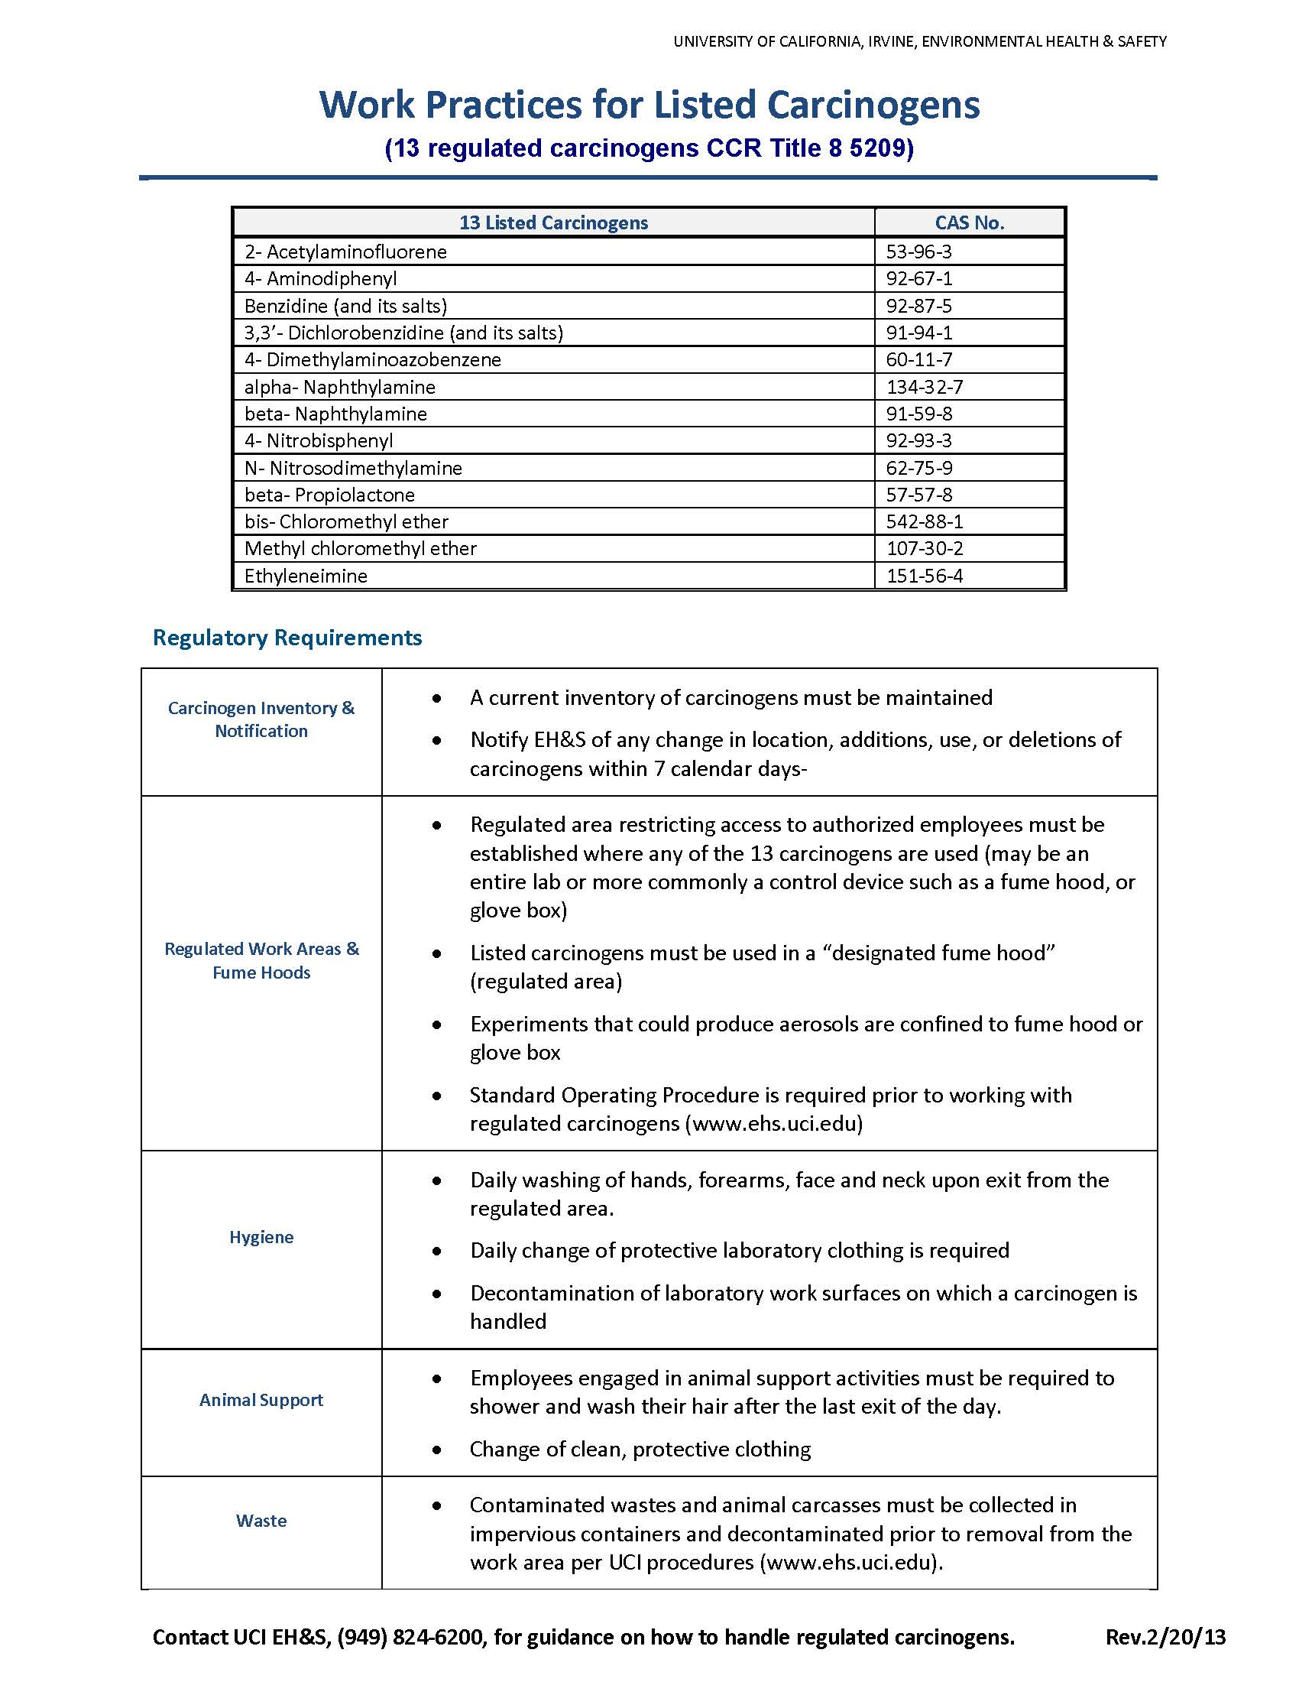

APPENDIX C:
Regulated Carcinogen Use Registration Form

